

**Bharti Kukreja**

Mobile: +91 9711198622/8297878622

Twitter id:

LinkedIn:

Email: bhartikukreja2015@gmail.com

Hyderabad

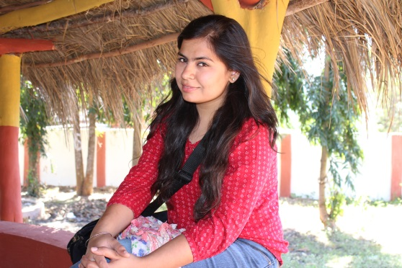

**Skills**

|  |  |
| --- | --- |
| Programming/Scripting Languages | R, JEE, J2SE, C, C++, Python, JavaScript, HTML |
| Databases | Oracle, MySQL, MongoDB |
| Repositories | Accurev, GIT and One Stash |
| Hadoop/Big data familiarity | HDFS, Spark, Kafka, HBase, Hive, Flume, Oozie |
| Tools | IBM SPSS, Tableau |
| Task tracking tool | Jira |

17th March 2017, **Geek Goddess** coding competition winner

* Worked on Web Services/Automation /Simplification/Support Projects in parallel using **agile** methodology.
* Acted as **ATF** for the team in absence of ATF for some releases.
* Provided **analytics training** to BI and DW team (80 members) in Verizon.
* Initiated **pilot group** with sales team for project adoption.
* **CSR** POC for Verizon, Team build organizer and core **PDC** member.

***Hello! I am Bharti***

I am data scientist/analyst graduated in Information technology from **GGSIPU** and majoring (CPEE) in big data analytics and optimizations from **INSOFE** certified by the LTI of **CMU**. Since my graduation, I have been working for **Verizon** Data Services India. I am passionate about coding and machine learning. I won **Geek Goddess** 2017 **coding** contest run by times now among 32k contestants from all over India. Giving back to society, learning new technologies, art n craft and dancing are energy drivers that put my creativity in motion.

**Achievements at work**

* VDSI Innovation spotlight award integrating Jira collector for Hygieia dashboard for DevOps cup.
* VDSI Innovation spotlight award for special recognition in VDSI Mega hackathon 2015.
* ERG recognition for most active fresher of 2015.
* ERG recognition CSR activities in 2016.
* ERG recognition for PDC and CSR in 2017.
* Spotlight award for analytics training 2017.
* Winning team caption for DPL 2017
* Silver and bronze Foosball winner in Gusto

29th June 2015, joined **Verizon** as a fresher

March 2014, paper “Empirical validation of multidimensional data models” presented in ICRITO 2014 & published in **IEEE** digital Xplore library

**Projects**

* ***VDSI:***

I am working on **sales funnel analytics** to get BI scores for customers and suggest sales representatives to target appropriate customers.

**Discount analytics** – it is basically a tool that simulates the win percentages on various discount percentages and suggest appropriate discount to be given for a customer.

**VES BI chat bot** for BI related reports and order status. This chat bot was build using java APIs and integrated with cisco jabber.

* ***Projects at INSOFE:***

**CDC (Change Data Capture) tool using Hadoop**

It is a tool to capture the changes from RDBMS database and replicate them on HADOOP. For RDBMS used MySQL and ingestion tool as sqoop to feed data in HIVE and HBASE.

**Prior authorization tool**

A prior authorization is an additional requirement that some insurance companies require before they decide if they want to pay for your medicine.

The goal is to develop an engine, for doctors that tell whether prescribed medication will require a prior authorization or not. This helps the doctors prescribe those medicines that do not require Prior Authorization in turn and reduces the service time for pharmacy, service process time for insurance, increases the probability of medication purchases and thereby improved health of patients.

This engine is based on advanced machine learning technologies that looks at the past transactional data and predict with high degree of confidence whether a particular drug will require prior authorization for a particular patient or not.

Also extract patterns of patients and drugs which require prior authorization, and the ability to analyze and understand what causes a drug to require prior authorization, and how to convert a drug that requires prior authorization to one that does not.

**Smart Spending Application**

An application that takes all the transaction messages from your phone, parses it and then classifies your expenditure into house hold, utility, entertainment and other categories. Text Mining is used as base approach.

**Instant liking predictor**

This tool forecasts the instant likelihood of a deodorant based on a large and comprehensive historical data set. This was done as part of geek goddess data science hackathon and gave 95% accuracy.

* ***Academic Projects*:**

1."e-IT HELP DESK” at Petrofac India Pvt. Ltd. Gurgaon: Intranet/desktop application in core java for an organization to provide ease to IT support system of company.

2. Online Shopping Website: It is a Web application to do online shopping. It is developed using Java Servlet with Oracle 10g Database.

4. Remote Desktop Service: It is an application that allows a personal computer’s desktop environment to be run remotely on one system, while being displayed on a separate client device. It is purely developed in Java.

**Other Achivements**

* **NIIT** certified C/C++ programmer.
* **NSDC** certified domestic data entry operator under IT-ITes SSC **NASCOM** 2014.
* I worked as a coordinator in publicity team of **AVENSIS**.
* Attended **GDG session** at Google India office on the eve of women’s day for code jam session, with **24** rank in hackathon.
* Received the **2012 DIRECTORS’ award** for academic excellence.
* Winners of inter college street play competition in **Atharva 2012** the Sushant Group of Institute’s annual fest.
* First prize in Ragnam at **ENVA 2013.**
* Second prize in rangoli making competition **GENESIS 2015.**